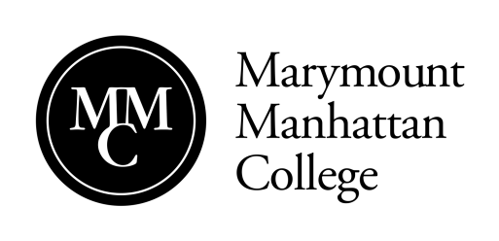

Summer 2019 Non-Credit Intensive Workshop MMC Student Application

Intensive(s) applying for:

[ ] Viewpoints Intensive (THTR INT WK1) $275.00
[ ] Chekhov Intensive (THTR INT WK2) $400.00
[ ] Combined Viewpoints/Chekhov Intensive (THTR INT WK3) $525.00
[ ] Lucid Body Basics Intensive (THTR INT WK4) $275.00
[ ] Stage Combat Certification Intensive (THTR INT WK5) $450.00

Note: You may register for more than one intensive, but please be aware that you will be registered and charged for each intensive you select.

Please Print

Name:

MMC Student ID#
Current Address: | __________________________________________________  Street Apt#  ________________________ _______ ________  City State Zip

Home Phone:
Cell Phone:
Email:

I understand that I am applying to participate in a non-credit intensive. I understand that to cancel my registration, I must email notice of that cancellation Jacqueline Noel (jnoel@mmm.edu) by 5/31/19. The cancellation date for the Lucid Body Intensive is 5/10/19. I understand that by failing to cancel my registration by the date indicated above, I will be responsible for the full workshop fee.

__________________________________________ ____/_____/____
Signature Date

Return Application to: Marymount Manhattan College
Department of Theatre
Attention: Brooke Harbaugh
221 East 71st Street
New York, NY 10021

